**OPERATING MANUAL**

**The LED Illuminating Light Fixture**

**«Bonus-8» SSO-A-220-020-N, T-MCC1,**

**TS 3461-005-41677105-09 OM**

The present operating manual (further named OM) is used for operating the LED illuminating light fixture “Bonus-8” (further named the light).

The OM contains construction data, operating rules and application characteristics, maintenance recommendations and other data necessary for the correct operation of the light.

Only after being instructed, going through safe working methods, checking of safety rules with further certifying a safety access qualification level, one is admitted for electrical installation, inspection and maintenance of the light unit.

**1. Description and Operating**

**1.1 Light Assignment.**

1.1.1 The light is used for general illumination of residential, industrial and public premises. The light can be mounted indoors and outdoors. The light can be used in industrial and commercial buildings.

**1.2 Technical data.**

1.2.1 Supply voltage range - 140 ÷ 265 VAC (50±10%) Hz or 200 ÷ 370 VDC;

1.2.2 Relative humidity up to 95% (at a temperature of +40°C).

1.2.3 Working temperature from minus 40°C up to plus 60°C.

1.2.4 Color temperature, K: T - (warm emission color) 3 000 ÷ 4 000, N (normal emission color) 4 000 ÷ 6 000.

1.2.5 Ripple factor of the light flux is not more than 5%.

1.2.6 Power factor is not less than 0.7.

1.2.7 Climatic category MCC1 according to IEC 60721-2-1:2013:1982, IEC 60068-1:2013.

1.2.8 Electric shock protection class 1 according to IEC 60598-1.

1.2.9 The lighting source – LED semiconductor module.

1.2.10 Ingress protection according to IEC 529 is not worse than IP65.

1.2.11 The light life cycle if conditions of operation are met is not less than 100 000 hours.

1.2.12 Shelf life from the manufacture date is 3 years.

1.2.13 Fire safety is up to NPB 249-97, IEC 60598-1.

1.2.14 Insulation resistance of live parts is not less than 20 МОm.

1.2.15 Grounding resistance is not more than 0.5 Оm.

1.2.16 The electrical and illuminating light parameters should correspond to the values given in Table 1.

Table 1

|  |  |  |  |
| --- | --- | --- | --- |
| The light brand | The light type | Light flux*, lm | Consumption power,  nominal, W, not more than |
| Bonus-8 | SSO-A-220-020-N,T-MCC1 | 990 | 10 |

* Light flux is specified for the LED module at the chip temperature of 25°C. To specify the light flux it is necessary to consider IES-file for the light.

1.2.17 The light weight, not more than 1.5 kg.

1.2.18 Overall view, maximum overall sizes and mounting dimensions of the light are given on pic.1

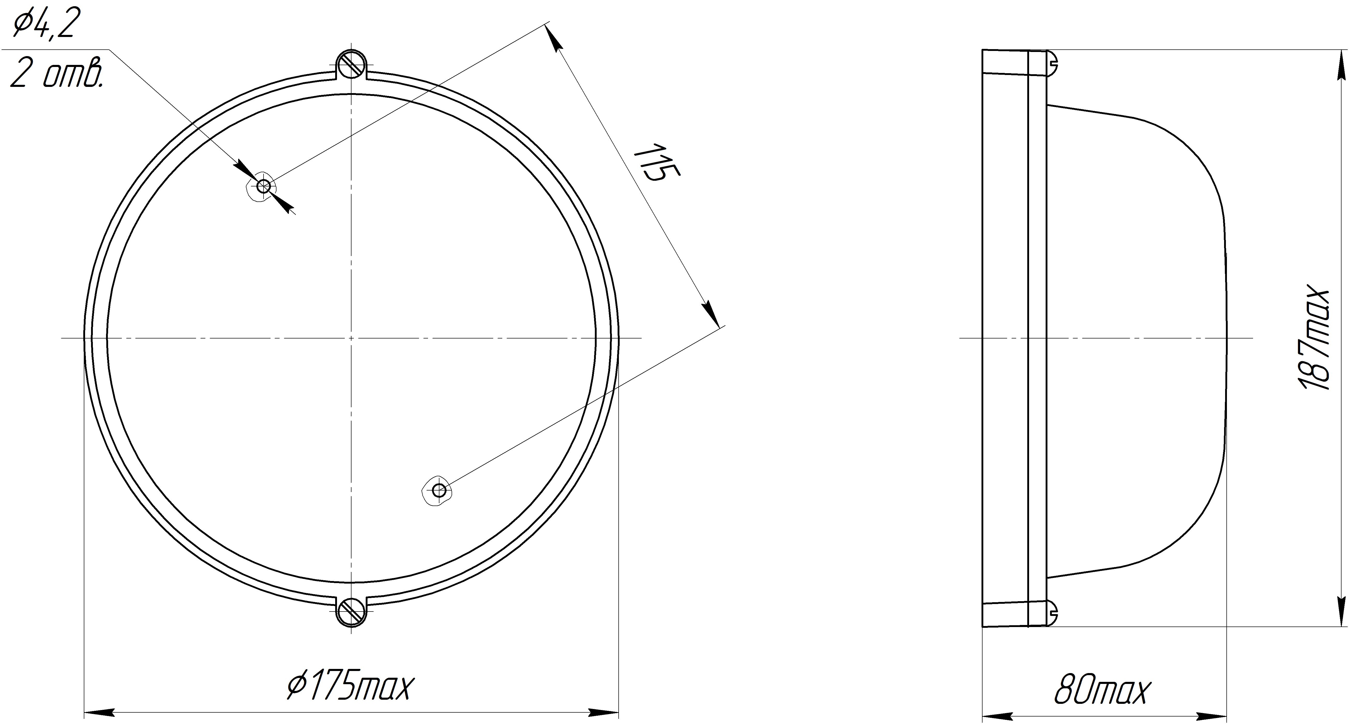

Pic.1

**1.3 The light completeness:**

1.3.1 The set consists of:

- a light – 1 pce.,

- an operating manual – 1 pce.,

- a passport – 1 pce.,

- a package – 1 pce.

**1.4 Construction and Operation**

1.4.1 The light (see Pic. 1) consists of a metal housing, as the structural element of the light, a cover glass, LED semiconductor modules, a driver and a contact device.

1.4.2 Application of the light component parts:

- a light housing is a structural element with installed LED semiconductor modules, a driver and a contact device for a power line connection;

- a cover glass is set on the light housing and fixed with frame with two screws, the glass is intended for a LED module, a driver and a contact device environmental protection.

**Notes:** the light construction is constantly developing, therefore it is a subject to changes without affecting on its reliability and technical parameters.

**1.5 Marking**

1.5.1 The light marking is made according to requirements of GOST 9980.4.

1.5.2 The light marking contains:

- the trademark of the manufacturer;

- the name of the manufacturer;

- the address of the manufacturer;

- the specification code;

- the brand and type of the light;

- nominal supply voltage, V;

- maximum power consumption, W;

- IP code;

- year and month of manufacture.

1.5.3 The type designation

SSO-Х-ХХХ-ХХХ-X-ХХХ

the letter designates a light curve group (A-cosine);

the three-number figure designates the nominal supply voltage;

the three-number figure designates a batch number;

the letter designates a light emission color (N – normal, T – warm);

the letters designate a climatic performance according to IEC 60721-2-1:2013:1982, IEC 60068-1:2013.

**1.6 Packaging**

1.6.1 The package of the light is made according to GOST 23216 for the storage requirements 2(c) according to **IEC 60721-2-1:2013:1982, IEC 60068-1:2013**.

1.6.2 The lights should be packed into a cargo container that provides their safety and protection against mechanical damages.

1.6.3 Manipulation signs should be marked on the cargo container: “Fragile”, “Keep dry”, “Top”, “Max quantity when stocking” according to ISO 780:2015.

**2 Intended Usage**

**2.1 Structural design.**

2.1.1 The structural design of the light is intended for illumination of residential and public premises, bathrooms, corridors, store rooms and etc.

**2.2. Preparation for Use.**

2.2.1 Installation of the light to the wall or the ceiling is done prior to connecting the light to the electrical network and the external grounding.

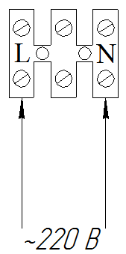

Рис. 2

2.2.2 To connect the light to the power line it is necessary:

- to take off the cover glass, unscrewing two screws of the frame;

- to insert the power line through the hole in the light housing and connect it to the contact device as it is shown on Pic. 2;

- to insert the external grounding wire and connect it to the connector “Заземление”;

- to install the cover glass with the frame into the light housing in reverse order.

**Notes:**

The light is equipped with technological wires connected to the network contact device. When the light is connected to the power line it is necessary to disconnect the technological wires.

**2.3 Safety Measures.**

2.3.1 For ensuring safety while operating the light it is forbidden:

- to carry out any operation of the light when energized;

- to assemble and operate the light with a damaged isolation of the wires.

2.3.2 When installing and operating the light it is necessary to follow:

- Rules of Electrical Facilities Maintenance;

- the present operating manual.

2.3.3 In order to avoid electric shock the light must be grounded.

**3 Storage and transportation**

3.1 The light should be kept packed according to GOST 23216 for the storage conditions 2 (c) **IEC 60721-2-1:2013:1982, IEC 60068-1:2013.**

3.2. Transportation of the light can be carried out by any kind of transport at any distance.

3.3. When keeping and transporting the light should be protected against any atmospheric fallout.

**4. Recycling**

4.1 All the materials used in the light are not dangerous for human life or health and the environment. On completing the operation of the light it should be disposed of in accordance with the present regulations.

**5. Warranty**

5.1 The manufacturer guarantees conformance of the light to requirements of technical specifications and normal work within 5 years since manufacture date if the customer meets requirements of transportation rules, storage, installation and operation.

5.2. Within the warranty period damaged lights should be changed charge free by the manufacturer in case of observing installation and operating rules by the customer.

**6 Reclamation Data**

6.1 The reclamation should be claimed to the supplier in case of discovering damages that may lead to the breakdown of the light before the warranty expiration.

The manufacturer address:

19, Leskova Str., Orel, 302040, RUSSIA, JSC “Proton”.

6.2 In reclamation the light brand, damages, conditions at which they are discovered, the whole operation period should be specified.

There should be attached a copy of the payment document for the light.

**7 Acceptance Certificate**

7.1 The light is manufactured and approved in accordance with the compulsive State standards requirements, the present technical specifications TS 3461–005–41677105–09 and approved to be suitable for the operation.

QCD stamp placeholder

________________________________

Date